End-to-End Data Pipeline & Predictive Analytics
Business Report
Brazilian Olist E-Commerce Dataset
ReadyNest Internship – Week 5
Prepared by: Ayush Sharma

Table of Contents
- 1. Executive Summary
- 2. Business Problem
- 3. Objectives
- 4. Dataset Overview
- 5. Project Architecture
- 6. ETL Pipeline
- 7. Data Cleaning & Feature Engineering
- 8. Exploratory Data Analysis
- 9. Machine Learning Pipeline
- 10. Dashboard Modules
- 11. Key Business Insights
- 12. Strategic Recommendations
- 13. Technology Stack
- 14. Project Outcomes
- 15. Future Enhancements
- 16. Conclusion

1. Executive Summary
This report presents a complete end-to-end analytics solution developed using the Brazilian Olist E-Commerce dataset. The project integrates data engineering, business intelligence, and machine learning into a single workflow. It transforms raw transactional data into actionable insights through an ETL pipeline, exploratory analysis, predictive modeling, and an interactive Streamlit dashboard.

2. Business Problem
E-commerce organizations need accurate visibility into sales performance, customer satisfaction, payment behaviour, and delivery efficiency. The objective was to build a unified analytics platform that supports operational and strategic decisions.

3. Project Objectives
- Develop a reusable ETL pipeline.
- Clean and integrate multiple relational datasets.
- Perform exploratory data analysis with business-focused visualizations.
- Train and evaluate machine learning models.
- Deploy an interactive Streamlit dashboard.
- Generate actionable business recommendations.

4. Dataset Overview
The project uses the Brazilian Olist public dataset containing customers, orders, order items, products, sellers, payments, reviews, geolocation, and category translation tables. These datasets were merged into a business-ready analytical dataset.

5. Project Architecture
Raw CSV Files
↓
ETL Pipeline
↓
Data Cleaning & Validation
↓
Feature Engineering
↓
Machine Learning Model
↓
Interactive Streamlit Dashboard
↓
Business Insights & Recommendations

6. ETL Pipeline
- Extract data from multiple CSV files.
- Validate schema and data quality.
- Remove duplicate records.
- Handle missing values.
- Convert date/time fields.
- Merge relational datasets.
- Engineer business features (delivery days, purchase month, payment metrics).
- Export processed_olist_data.csv.

7. Data Cleaning & Feature Engineering
Missing values were treated using appropriate strategies, duplicate records removed, and derived features such as Delivery Days, Purchase Month, Customer State, Seller State, Payment Installments, and Payment Value were created.

8. Exploratory Data Analysis
EDA identified revenue trends, product performance, customer behaviour, review score distribution, payment preferences, delivery performance, and regional sales patterns using interactive visualizations.

9. Machine Learning Pipeline
Component | Details
Target | Customer Review Score
Models Evaluated | Logistic Regression, Decision Tree, Random Forest
Selected Model | Random Forest
Deployment | best_model.pkl integrated into Streamlit

10. Dashboard Modules
- Executive Dashboard
- Sales Analytics
- Customer Analytics
- Product Analytics
- Payment Analytics
- Delivery Analytics
- ML Prediction
- Business Insights
- Strategic Recommendations
- About Project

11. Key Business Insights
- Revenue is concentrated in a small number of product categories.
- Delivery performance has a strong relationship with customer satisfaction.
- Digital payment methods dominate transactions.
- Regional analysis identifies high-performing markets.
- Interactive filters support faster decision-making.

12. Strategic Recommendations
- Reduce delivery delays through logistics optimization.
- Increase marketing investment in top-performing categories.
- Monitor seller quality continuously.
- Promote preferred payment methods.
- Use ML predictions to identify satisfaction risks.

13. Technology Stack
Python • Pandas • NumPy • Scikit-learn • Plotly • Streamlit • Joblib • Git • GitHub

14. Project Outcomes
• Automated ETL Pipeline
• Business Intelligence Dashboard
• Predictive Machine Learning
• Executive KPIs
• Business Insights
• Strategic Recommendations

15. Future Enhancements
Real-time data ingestion, cloud database integration, automated model retraining, explainable AI, forecasting, and CI/CD deployment.

16. Conclusion
The project demonstrates practical capabilities in data engineering, analytics, machine learning, and dashboard development. It provides a scalable decision-support solution for e-commerce stakeholders.

Appendix deployment URL, and additional visualizations on this page before final submission.
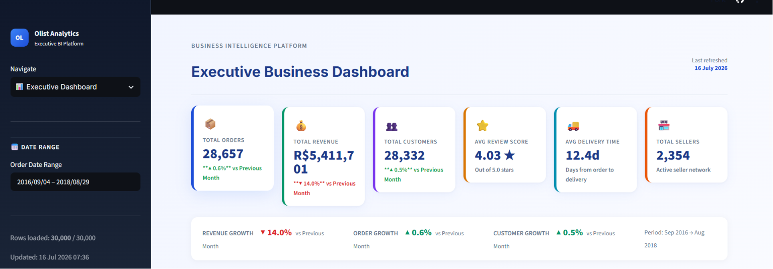
Dashboard
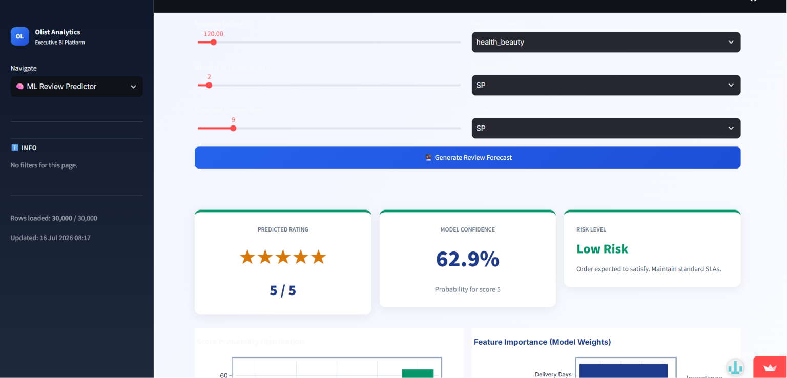
ML-Powered Customer Review Score Predictor
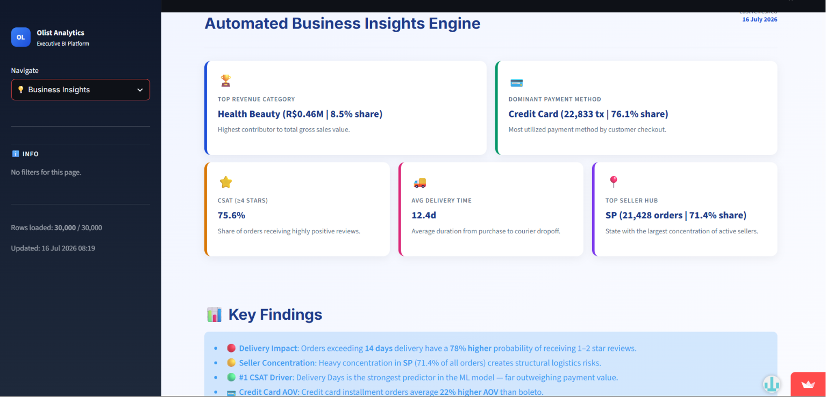
Business Insight
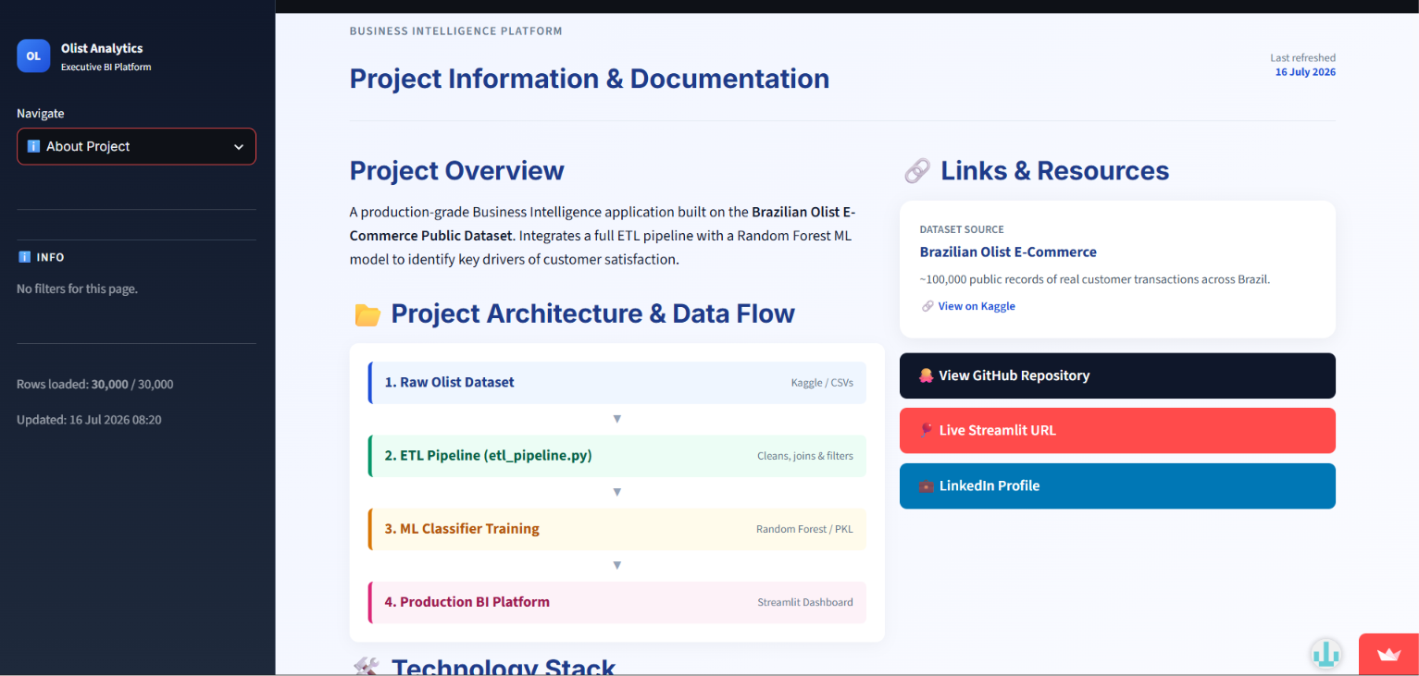
About Project
[Github rep link](https://github.com/Sharmaayush29/olist-analytics-dashboard.git)
[Live Streamlit link](https://olist-analytics-dashboard-ayushsharma.streamlit.app/)

